THE 8922 WEBSITE LISTING THE VACANCY FOR THE LAURENTIDE REGION

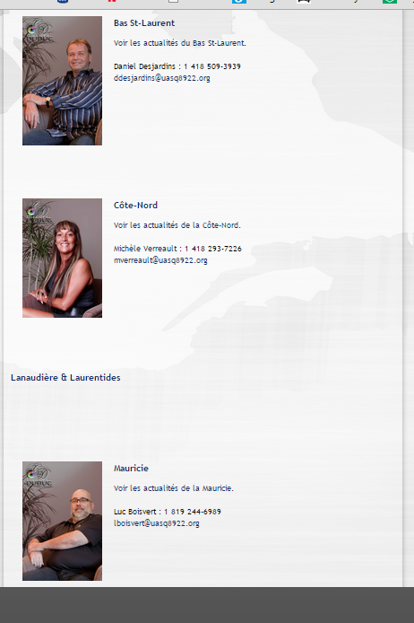

THE 8922 BI-MONTHLY MAGASINE:
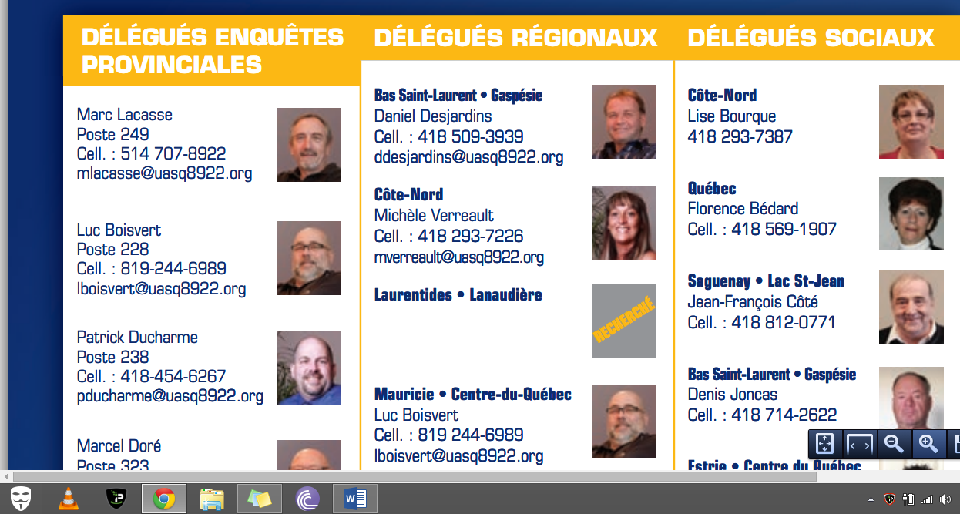
*Their magazine has listed that position as vacant since at least October 2014.

